Calculus 1 Name
Review for Graphing & Application of Derivatives (A) Block Date

1) Find the requested information for the given function, then sketch a graph.
C.V. C. V.
Inc. C. U.
Dec. C. D.
Extreme Value(s): Point(s) of Inflection:

4) Determine if the mean value theorem applies to the given interval? If not, state why. If it does work, calculate the value of x at which it occurs. $f(x)=\frac{6}{x}−3$ on the interval [1,2]

5) Find the absolute minimum and absolute maximum values of $f(x)$on the given interval.
$f(x)=x^{3}−\text{12}x+1$, [-3,5]

6) Sketch a graph of the function from the given information.

7) Given the following graph, label the absolute max & min, and the relative max & min.

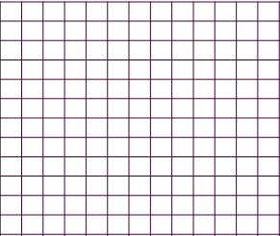
8) Given the function Answer the following questions, showing all work.

Domain: Range:

y-intercepts: x-intercepts:

First derivative:

Increasing:
Decreasing: What is the equation of the tangent line at x=-2?

Second derivative:

Concave up:
Concave down: What is/are the equation(s) of the tangent line
at the extreme value(s)?
Extreme Value(s):

Point(s) of inflection:

